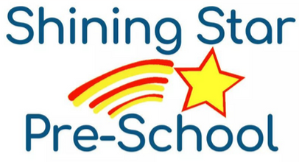
Dear Shining Star Families,

Shining Star Preschool does participate in, and follow the guidelines for, the Child and Adult Care Food Program (CACFP.) The CACFP is a federal program that provides reimbursement to facilities that provide nutritious meals, and snacks to eligible children. Our program provides meals (breakfast, lunch, and PM snack) to all children that are present at mealtimes.
We require all families to fill out these forms: Household Income Eligibility Statement, and the Participant Enrollment Form.

The Household Income Eligibility Statement requires ALL people living in the residence (related and unrelated) to be listed. The Participant Enrollment Form requires the name of the child(ren) in care, as well as the times they will be attending. For families with multiple children in our programs one (1) Household Income Eligibility, and one (1) Participant Enrollment Form can be turned in with both children listed in the provided spaces.
Please complete these forms and return them, along with two most recent paystubs, with the rest of the enrollment paperwork. If you have any questions, or need any additional information about these forms, please contact us!

Sincerely,
Ms. Elaine
Owner and Director of Shining Star Pre-school, LLC
(586) 731-3344
MsElaine.ShiningStar@gmail.com

